Bootloader Note

Monday, January 2, 2023

1. Stm32F4x_bootloader.py function:

no GUI with it. Debugged with Visual Studio Code Version 1.65.0 and stm32F411 Nucleo board.

The python script calls ST bootloader commands to perform the following tasks:

Erasing the Flash Section 7;

Then, writing the example bin file user_app.bin to the flash whose address starts from 0x0807c010. (This address can be changed by changing conf’s address in the code.)

Verifying the codes.

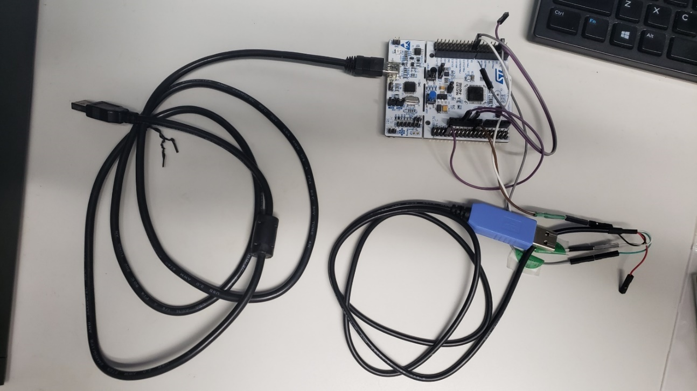

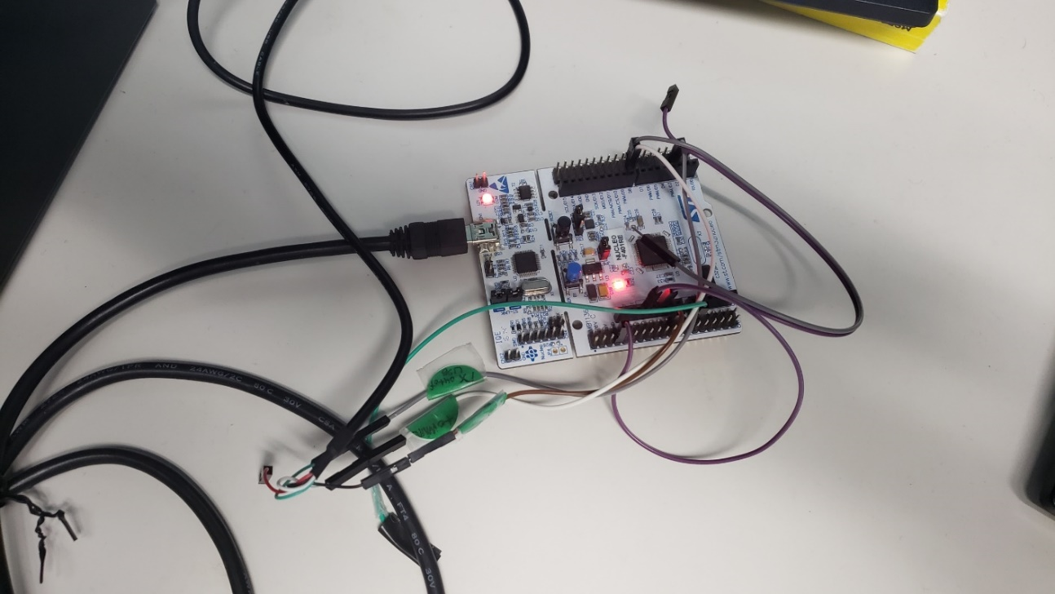

The pin BootMode0 of Nucleo board should be set to 3.3V, BootMode1 should be set to 0 V.

1. Use Hex Editor Neo to read and edit the bin file as below:

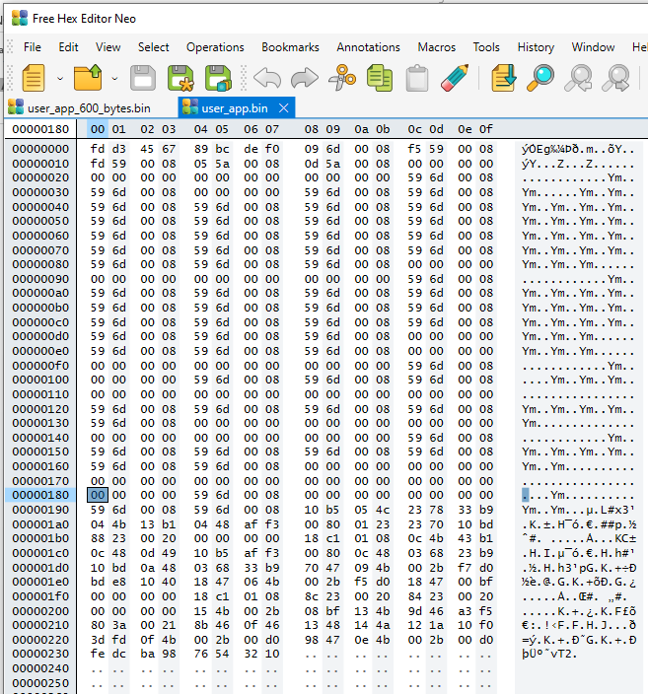

1. Use STM32CubeProgrammer to read the STM32F411 Nucleo board flash to confirm the writing.

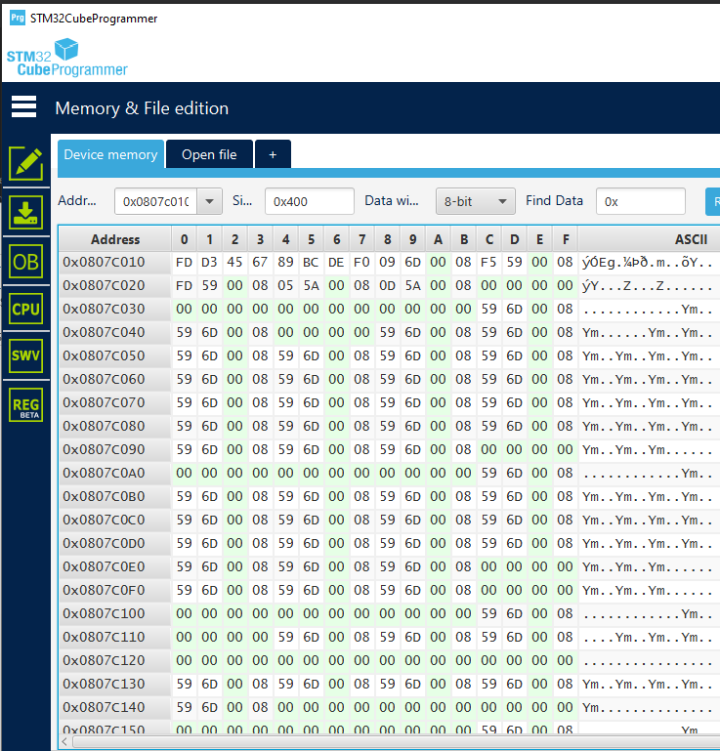

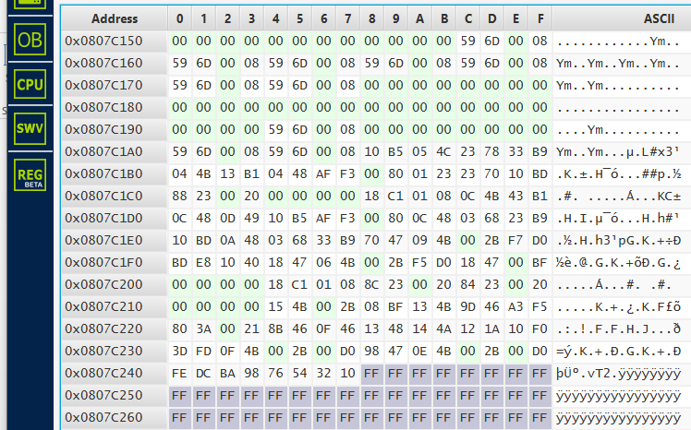

1. Reference:

Stm: AN2606_STM32 microcontroller system memory boot mode.pdf

Stm: AN3155_USART protocol used in STM32 bootloader.pdf

1. <https://github.com/florisla/stm32loader> florisla very important
2. <https://github.com/jsnyder/stm32loader/blob/master/stm32loader.py>, jsnyder
3. <https://github.com/pavelrevak/stm32bl/blob/ae908e34cdb727808817d2d04a6dbc752a5b22f8/README.md>
4. <https://blog.csdn.net/qq_34254642/article/details/102887517> chinese
5. <https://www.bilibili.com/video/BV1Ub4y167XQ/?spm_id_from=333.788.recommend_more_video.-1>, STM32+IAP上位机程序讲解
6. <https://www.youtube.com/watch?v=GR8Vy5QvDHU> STM32 Tips: Talking to the on-board Bootloader
7. Extra tool

AccessPort is useful for sending STM Bootloader command one-by-one to F411 Nucleo board.

